VFW Auxiliary Department of South Dakota

**Veterans & Family Support August 2024**

*National Theme: From Our Roots to Our Branches*

Extending Service to Our Veterans

***Department Theme: United in Service for Veterans***

**2024-2025 Dept. Chairman: Tammy Chase**

**45980 SD Hwy 10**

**Sisseton, SD 57262 (605) 698-7438**

[**cbchase@venturecomm.net**](mailto:cbchase@venturecomm.net)

**Program Goals: Veterans & Family Support Goals:**

1. A close-up of a logo

   Description automatically generated**Support VFW National Services (NVS)**
2. **Support VFW Veterans & Military Support Programs**
   1. **Military Assistance Program (MAP)**
   2. **Unmet Needs**
   3. **VFW “Sports Clips Help A Hero Scholarship Program**
3. **Assist Veterans**
4. **Assist Service Members & Their Families**
5. **Promote Veterans & Military Suicide Prevention & Mental Health Awareness**

November is the month of the MILITARY FAMILY. Take time to thank and hour our military families. The families are the ones that stay behind and keep things going smoothly so that the military member can preform there duties and come home safely, be it from a weekend drill, deployment, AT (annual training or military schools. You can send a card, take them over some treats throughout the month.

Do you know what the coins on Veterans Headstones mean? According to tradition, the money left at graves in national cemeteries and state Veterans cemeteries is eventually collected, and the funds are put toward maintaining the cemetery or paying burial costs for indigent Veterans.

Make sure to track you activities and hours on www.vfwauxsd.org

Veterans Day – November 11

**Month of the Military Family**

**November**

**You know service is an honor.**

You are the backbone of our military. You are the quiet, but steady fuel at home that keeps the fire burning. You keep track of military pay, benefits and news, because you know they make a daily difference in your life. And when your time as an actively serving family comes to an end, you support your Veteran, and other military members.

**Serving is just what you do.**

Traditionally, the president signs a proclamation recognizing that service and declaring November as Military Family Month. Over the month, families just like yours are honored and recognized for their commitment and contributions in support of our military and nation. (Military.com)

**Why Is National Military Family Month Important?**

* Acknowledgment of Sacrifice: Military families often endure long separations, frequent moves, and the emotional toll of having a loved one in a dangerous line of work.
* Community Support: The month serves as a rallying point for communities to show their support for military families.
* Policy Focus: It brings attention to the policies affecting military families, encouraging lawmakers to consider their unique needs.
* Emotional Well-Being: The month-long observance can serve as a morale booster for both service members and their families.

For an in-depth look at how military service impacts family dynamics, read[The Impact of Military Service on Family Dynamics](https://nvhs.org/the-impact-of-military-service-on-family-dynamics/).

**The Intersection With National Veterans and Military Families Month**

November is also recognized as National Veterans and Military Families Month. While National Military Family Month focuses on the families, National Veterans and Military Families Month is broader, including both veterans and their families. The two observances complement each other, emphasizing the collective sacrifices made by those who serve and those who support them.

**How to Participate**

* Attend Local Events: Many communities host events in honor of military families.
* Volunteer: Offer your time to organizations that support military families.
* Donate: Consider making a financial contribution to reputable organizations focused on military family support.
* Social Media: Use the hashtag #MilitaryFamilyMonth to spread awareness.

National Military Family Month serves as a crucial reminder of the sacrifices and challenges faced by military families. It is a time for the nation to come together to offer their support and gratitude. By understanding its significance, we can all contribute to making the lives of military families a little better.

[National Veterans Homeless Support](https://nvhs.org/) seeks to eliminate homelessness among veterans. The month of November and throughout the entire year, we can keep the homeless Veterans and families in our thoughts and prayers. It would be a good time to give them some food or clothing.

Thank you to the military members for your service. We also want to take this opportunity to thank the FAMILY of the military members for their service and continued support!

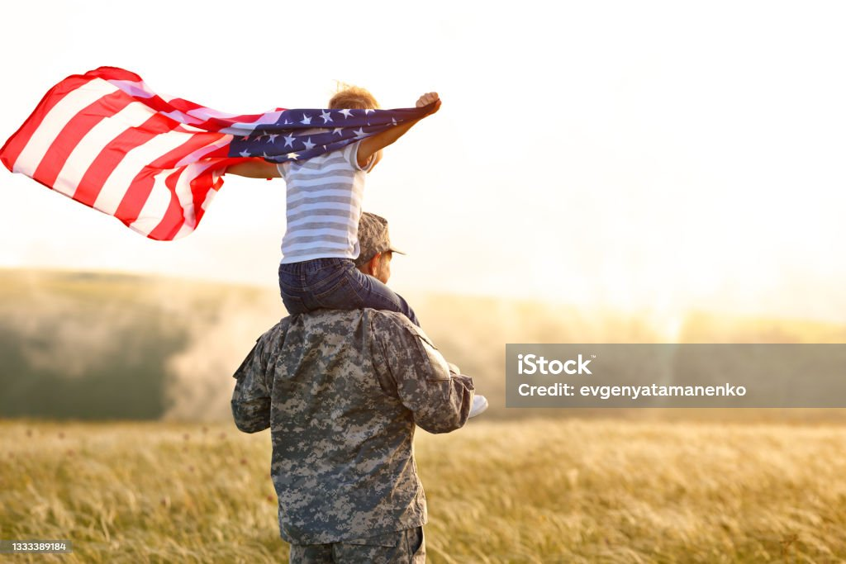

November – Happy Military Family Month

SD VFW Auxiliary

Veterans & Family Support